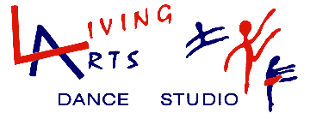
HAPPY BIRTHDAY!
Have Living Arts Dance Studio host your next Birthday Party and be the talk of the town!
We will work with you to design a party appropriate for your child’s age and interest.

A Living Arts Birthday party is held at our spacious studio. You will have use of the whole facility for your party. You may bring a cake, juice boxes, plate, utensils, etc. Instead of cake you can bring cupcakes or cookies. You may also serve food such as pizza or sandwiches.
The party includes a trained Living Arts Instructor to supervise and instruct the children. This includes play time/activities and time for the children’s refreshments and gift opening. We have plenty of props and fun activities for the little ones too! These are just some of the ideas we have to make your next Birthday Party the best ever!
*Fairy Princess *Hawaiian Luau
*Night at the Disco *Hip-Hop Hurray!
*Pajama Party *Super Hero’s
*That’s So 80’s *Holiday Related Themes

Parties are available for children ages 3 and up. Our parties are limited to a total of 8 children. There is a $10 fee per child for attendance over 8.
A 50 % deposit is required to reserve a party date. The balance is due the date of your party. Please make payments in cash, charge, or checks made payable to Living Arts Dance Studio.

Party Fee: $100.00 (2 hour maximum time period)
For more information call 517-819-9361 or email us at susan@livingartsdancestudio.com. We’re looking forward to your special day! And we’ll clean up the mess!

BOOK YOUR PARTY TODAY!

